# Landing Pages

Landing page includes the page you initially navigate to and also the sidebar menu items and black menu bar. Does not include the Red Menu bar on top

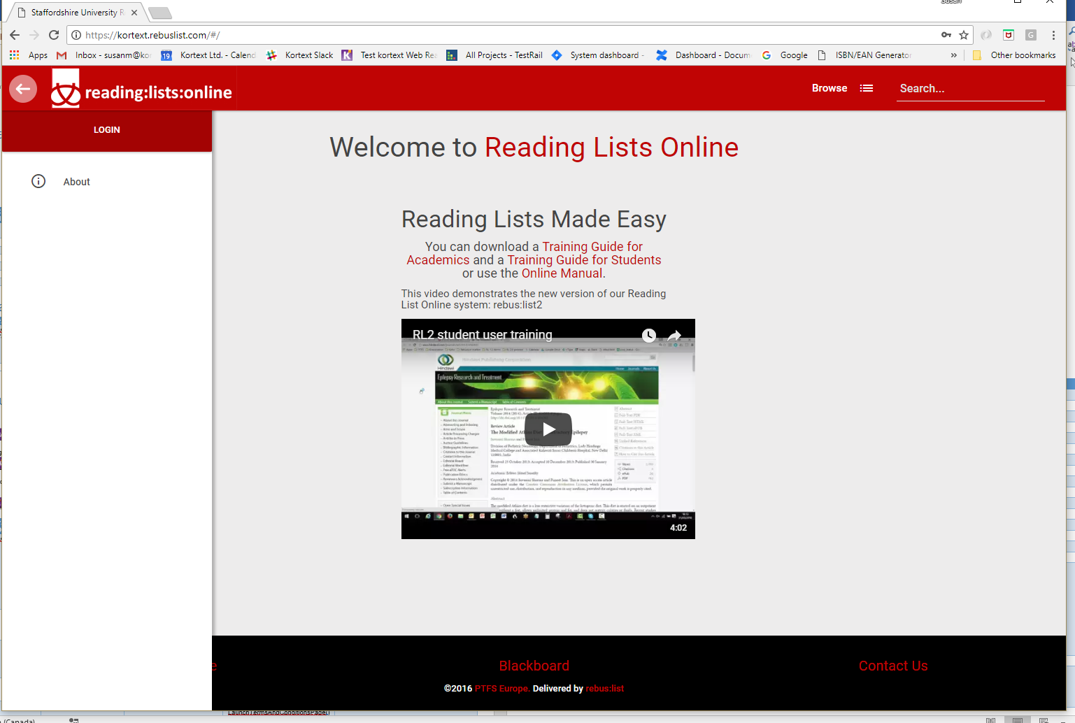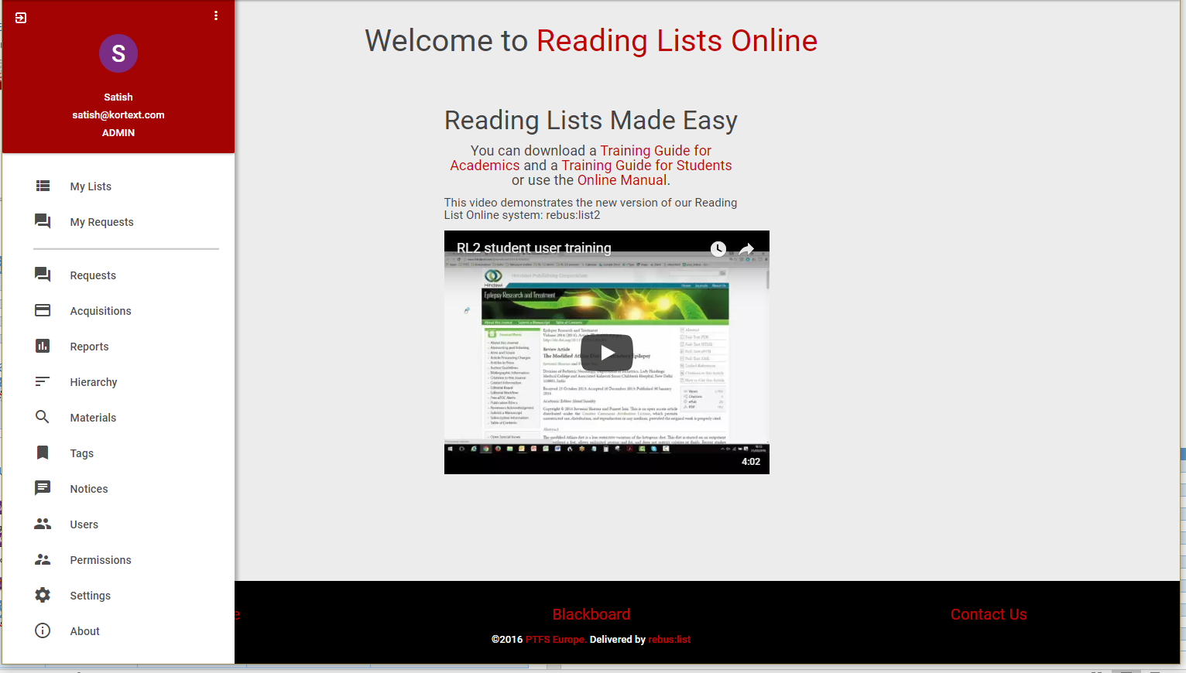

|  |  |  |  |  |
| --- | --- | --- | --- | --- |
| Class Names | Functionality | Page Objects | Commands | Notes |
| Landing Page | Includes sidebar menu items | LandingPage.cs | public void GoToLandingPage() | Navigate to base kortext.rebuslist.com From here you can log in. |
|  | Login Button |  | public void ClickOnLoginBtn() |  |
|  |  |  | public bool LoginButtonIsDisplayed() | Checks if the login button is displayed in the landing page menu sidebar |
|  |  |  | public void ClickOnUserMenuBtn() |  |
|  | Logout icon |  | public void Do_Logout() | Logs current user out. |
|  |  |  | public bool IsLoggedOut() | Checks if the user is actually logged out or not. |
|  |  |  | public bool IsLoggedIn() | Checks if the user is logged in. Returns true if they are |
|  |  |  | GetGreenToasterMsg – not implemented |  |
|  | Sidebar Menu items – opens supporting pages |  | public void ClickOnMenu_MyListsBtn() |  |
|  |  |  | public void ClickOnMenu_MyRequestsBtn() |  |
|  |  |  | public void ClickOnMenu_RequestsBtn() |  |
|  |  |  | public void ClickOnMenu_AcquisitionsBtn() |  |
|  |  |  | public void ClickOnMenu_ReportsBtn() |  |
|  |  |  | public void ClickOnMenu_HierarchyBtn() |  |
|  |  |  | public void ClickOnMenu_MaterialsBtn() |  |
|  |  |  | public void ClickOnMenu_TagsBtn() |  |
|  |  |  | public void ClickOnMenu_NoticesBtn() |  |
|  |  |  | public void ClickOnUserMenuBtn() | Opens PearlUsersPage |
|  |  |  | public void ClickOnMenu_PermissionsBtn() |  |
|  |  |  | public void ClickOnMenu_SettingsBtn() |  |
|  |  |  | public void ClickOnMenu_AboutBtn() |  |
|  | Footer Links |  | public void ClickOnFooter_LibraryHome() |  |
|  |  |  | public void ClickOnFooter_BlackboardLink() |  |
|  |  |  | public void ClickOnFooter_ContactUsLink() |  |
|  |  |  | public void ClickOnFooter_PTFSEuropeLink() |  |
|  |  |  | public void ClickOnFooter_rebuslistLink() |  |
|  |  |  |  |  |

# Pearl Login Page

The popup modal for logging in

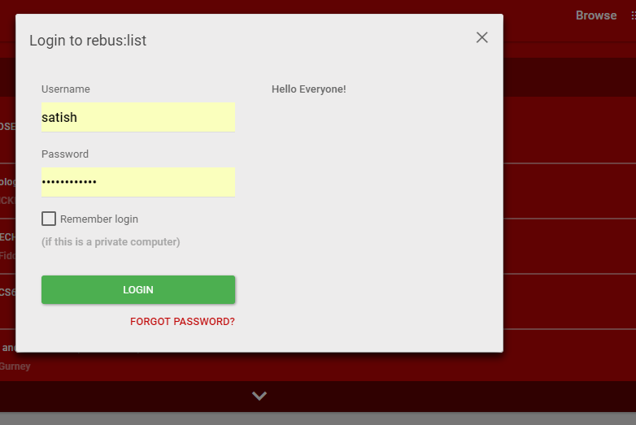

|  |  |  |  |  |
| --- | --- | --- | --- | --- |
| Class Names | Functionality | Page Objects (CS File) | Commands | Notes |
| PearlLoginPage |  |  | public bool IsAtPage() | Checks if the green login button is displayed. Use this to see if this modal appears. |
|  | Logs into the application. Returns error messages |  | public PearlLoginPage LoginAs(string password) | Tests sending password only |
|  |  |  | public PearlLoginPage LoginAs(string username, string password) |  |
|  |  |  | private void PerformLogin(string username, string password) | Takes a user name and password and attempts log in |
|  |  |  | public string GetMessage() | Gets any error message from invalid log ins |
|  | Remember Me keeps you logged in |  | Remember Me button – not implemented yet |  |
|  | Forgot password resets password |  | Forgot password – not implemented yet |  |
|  |  |  |  |  |
|  |  |  |  |  |

# Red Menu Page

Red menu page include all of the menu items inside the top red menu. Includes Search Functionality too.



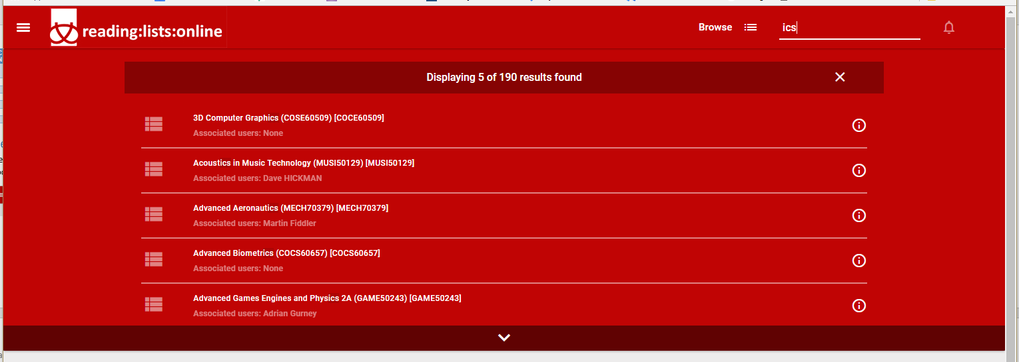

|  |  |  |  |  |
| --- | --- | --- | --- | --- |
| Class Names | Functionality | Page Objects (CS File) | Commands | Notes |
|  | Rebus Labe |  | public void ClickOnRebusLabelBtn() | Returns you to the landing page |
|  | Main Menu hamburger icon |  | public void ClickOnMainMenuBtn() | Opens the sidebar in the landing page |
|  | Browse RLMS |  | public void ClickOnBrowseBtn() | Opens the Browse Page |
|  | Search for a string |  | public string SearchRebus(string searchstr) | Enters a search string and returns a string containing search result counts |
|  |  |  | public bool TraveltoFirstResult() | compares the first list in the search results to the page that comes up when you click it. |
|  |  |  | public bool ValidateResultsCleared() | Validates clear button works |
|  |  |  | public void ClearResults() | Clicks on clear result button |
|  |  |  | public bool ValidateSearchResults(string search_str) | Validates that the search results all contain the passed in string. Use after SearchRebus with same string |
|  |  |  | ClickOnNotificationIcon – Not implemented |  |
|  |  |  |  |  |
|  |  |  |  |  |
|  |  |  |  |  |
|  |  |  |  |  |
|  |  |  |  |  |
|  |  |  |  |  |
|  |  |  |  |  |

# Users Page

Search for, add or edit users.

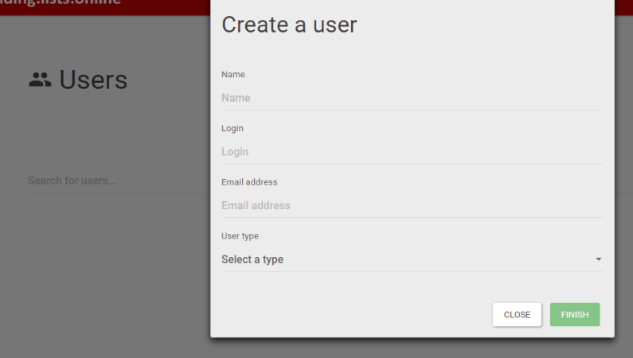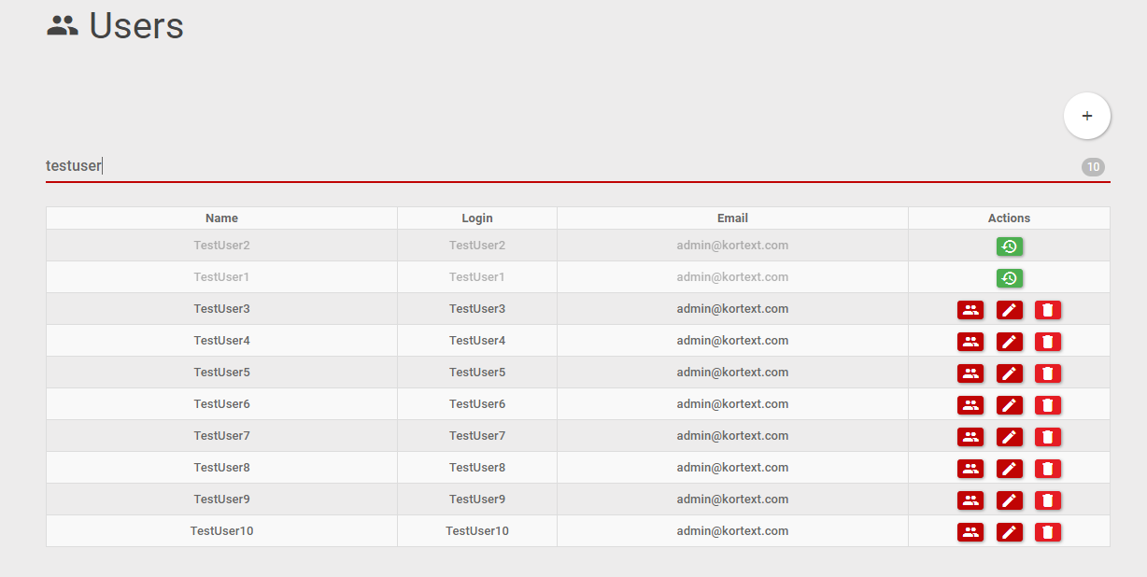

|  |  |  |  |  |
| --- | --- | --- | --- | --- |
| Class Names | Functionality | Page Objects (CS File) | Commands | Notes |
| PearlUserPage |  | PearlUsersPage.cs | public bool GoToUserPage() | Opens user pages calls landing menu options. |
|  | Search for and return matching users |  | public bool UserExists(string username) | Returns true if an exact match is found. |
|  |  |  | private int CountOfUsersReturned() |  |
|  | Add a new User |  | public bool AddUserDefault(String username = "TestUser", String usertype = "Librarian", String email = "admin@kortext.com") | Adds a new user with the prefix of username + a number. Allows you to pass the username, user type and their email. Leaving them blank defaults to TestUser, Librarian and [admin@kortext.com](mailto:admin@kortext.com). Confirms that the user was successfully created. |
|  |  |  |  |  |
|  |  |  | public bool UserExists(string username) | Checks if the named user exists or not. Will find exact match |
|  |  |  | private string SearchAndReturnNewUserName(string username) | Not available publicly. Returns new user name by appending number to set string. TO BE MODIFIED TO ACCEPT STRING |
|  | Edit User Role |  | public bool EditUserRole(string username, string userrole) | Accepts:   * LIBRARIAN * ADMIN * PUBLIC * STAFF * STUDENT |
|  |  |  | private bool ValidateUserRole(string username, string userrole, string origrole) | Validates the user role was changed correctly. Called by EditUser |
|  | Edit User Info |  | Not implemented yet. |  |
|  |  |  |  |  |
|  | Restore an inactive user |  | Not implemented yet. |  |
|  | Edit List Roles |  | Not implemented yet. |  |
|  | Delete a user |  | Not implemented yet. | Delete user (make inactive) |
|  | Utilities |  | private void ClickOnPasswordResetBtn() | Only for use when add or edit user modal is open |
|  |  |  | private void ClickOnCloseBtn() | Only for use when add or edit user modal is open |
|  |  |  | private bool ValidateUserRole(string username, string userrole) |  |
|  |  |  | private bool ClickOnUserBtns(string username, UserActionBtn which_button) | Finds a named user with exact match and then clicks on one of the buttons:   * editUserBtn * editListRoleBtn * deleteUser   restoreUser |
|  |  |  | private bool SelectUserType(String usertype) | Selects the user type from a drop down of different types. Not available publicly. |
|  |  |  |  |  |
|  |  |  |  |  |
|  |  |  |  |  |  | private bool SelectUserType(String usertype) | Selects the user type from a drop down of different types. Not available publicly. |
|  |  |  |  |  |
|  |  |  |  |  |
|  |  |  |  |  |
|  |  |  |  |  |
|  |  |  |  |  |
|  |  |  |  |  |
|  |  |  |  |  |
|  |  |  |  |  |
|  |  |  |  |  |

# Hierarchy Page

Hierarchy is the structure of the units and lists present for the institute. Each instance of RLMS is for a single university.

A Hierarchy has:

Unit-> List(s) ->Section(s)->SubSection(s). Materials can be added at Section Levels or SubSection Levels. Lists can be edited in a buffer. Then saved and published.

A Unit can have a Child Unit.

In Hierarchy view, Sections and Subsections are not shown.

Buffer is the place where we make changes to the list (sections, subsections, items)

This hierarchy page represents the functions a university would perform on their units and lists. It is different than the Buffer pages where material is added to a list, and sections and subsections.

|  |  |  |  |  |
| --- | --- | --- | --- | --- |
| Class Names | Functionality | Page Objects (CS File) | Commands | Notes |
| PearlHierarchyPage |  | PearlHierarchyPage.cs |  |  |
|  | Unit - Create new Unit |  | public bool CreateNewUnit(string unitname, string coursetextstring) | Opens Hierarchy page and creates a new unit with passed in name and course text. |
|  | Unit - Delete |  | public bool DeleteUnit(string unitname, string unitcourseidentifiertext, string cancel_or_confirm) | Deletes a unit. By specifying either cancel or confirm, you can cancel a delete or proceed.   * Cancel * Confirm |
|  | Unit - Add Child Unit  Unit - Add List |  | public bool AddChildUnitList(string unitname, string childunitname, string unitcourseidentifiertext, string unit_or_list) | Adds either a child unit or a child list to a given unit.   * Unit * List |
|  | Utilities |  | public IWebElement FindUnit(string unitname, string unitCourseIdentifierText) | Finds a first level unit. Returns the container for that unit if found or null if not. |
|  |  |  | public IWebElement FindSubChildUnit(string unitname, string childunitname, string unitcourseidentifiertext) | Finds a child of a unit 1 level deep. Must pass in both name of unit and child name. Returns the container for the child unit or null if not found. |
|  |  |  | private bool FillInNew_UnitOrList_Form(string unitname) | Fills in a unit or list form once it has appeared on the screen. Assumes the popup is there. |
|  |  |  | private bool DeleteThisElement(IWebElement UnittoDelete, string cancel_or_confirm) | Deletes a container if able |
|  |  |  | private bool ExpandUnit(IWebElement thisunit) | Expands a container if it needs it. |
|  | Unit - Edit User Roles |  |  |  |
|  |  |  |  |  |
|  | Unit - Edit Metadata |  | public bool EditUnitMetadata(string unitname, string unitcourseidentifiertext, FieldToChange field, string newvalue) |  |
|  |  |  | public bool ValidateMetadataChange(string unitname, string unitcourseidentifiertext, FieldToChange field, string newvalue) | Validates that the metadata contains the passed in value for a specified field. Only works for Name, Course Identifier and year. Have yet to find how to extract the remaining info |
|  |  |  |  |  |
|  | Unit - Suppress/Unsuppress |  | Needs to be rewritten |  |
|  | List - Suppress/Unsuppress |  | Needs to be rewritten |  |
|  | List - Edit User Roles |  |  |  |
|  | List - Edit Metadata |  | public bool EditChildMetadata(string unitname, string childunitname, string unitcourseidentifiertext, FieldToChange field, string newvalue) |  |
|  |  |  | public bool ValidateChildMetadataChange(string unitname, string childunitname, string unitcourseidentifiertext, FieldToChange field, string newvalue) | Validates that the metadata contains the passed in value for a specified field. Only works for Name, Course Identifier and year. |
|  | List - Delete |  | public bool DeleteChild(string unitname, string childname, string unitcourseidentifiertext, string cancel_or_confirm) |  |
|  | Move Lists - Moving to Same Unit |  |  |  |
|  | Move Lists - Moving to Different Unit |  |  |  |
|  | Clone Lists - Cloning to Same Unit |  |  |  |
|  | Clone Lists - Cloning to a Different Unit |  |  |  |
|  | Clone Lists - Cloning to itself |  |  |  |
|  | Roll Lists - Archive |  |  |  |
|  | Roll Lists - No Archive |  |  |  |
|  | Roll Lists - Roll over a Unit/List |  |  |  |
|  | Roll List - Roll Entire Hierarchy |  |  |  |
|  |  |  |  |  |
|  |  |  |  |  |
|  |  |  |  |  |
|  |  |  |  |  |